Chapter 18, Problem 35.

A signal f(t) has Forier transform

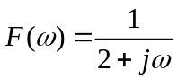

Determine the Forier transform of the following signals:
- x(t) = f(3t – 1)
- y(t) = f(t) cos 5t
- 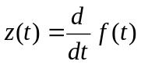
- h(t) = f(t)*f(t)
- i(t) = tf(t)

